Python Data Analytics Notes: Day 26

1. Introduction to Matplotlib
Before plotting, we import the necessary libraries. matplotlib.pyplot is the module most commonly used for creating plots and is imported with the standard alias plt.
Python
import numpy as np
import pandas as pd
import matplotlib.pyplot as plt

import warnings
warnings.filterwarnings('ignore')

2. Line Plots
Definition
A line plot connects individual data points with a straight line. It is especially useful for visualizing trends and changes in data over a continuous interval or sequence, such as time. The primary function is plt.plot().
Example 1: A Simple Linear Plot
Here, we plot a simple list of numbers against itself, which results in a straight diagonal line.
Python
# Data for the plot
a = [1, 2, 3, 4, 5]
b = a # y is the same as x

# Create the plot
plt.plot(a, b)

# Display the plot
plt.show()

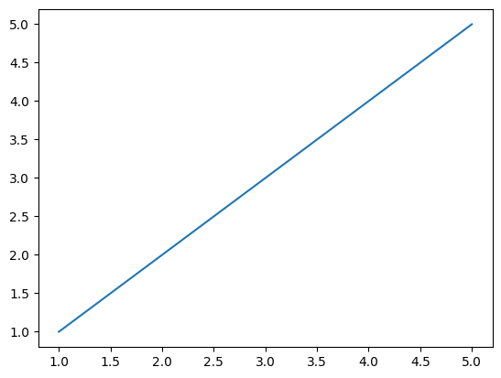
Example 2: Plotting Two Lists
This example shows a plot of x and y where the values are not linearly related, resulting in a plot that shows fluctuations.
Python
# Data for the plot
x = [2, 4, 6, 8, 10, 12, 14]
y = [35, 67, 34, 24, 56, 39, 78]

# Create the plot
plt.plot(x, y)
plt.show()
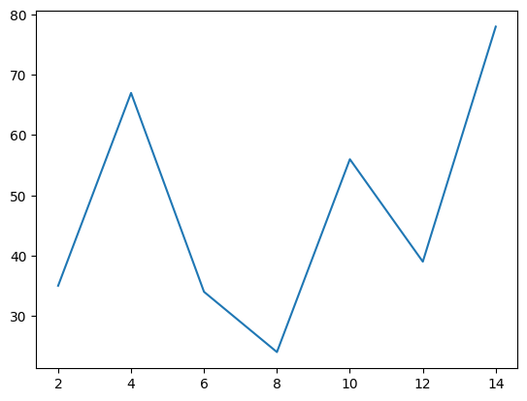
Example 3: Plotting a Mathematical Function (Sine Wave)
We can use NumPy to generate an array of values (e.g., from 0 to 10 with a step of 0.1) and then plot a mathematical function, like np.sin(), applied to that array.
Python
# Generate x values from 0 to 10
x = np.arange(0, 10, 0.1)

# Calculate the sine of each x value
y = np.sin(x)

# Create the plot
plt.plot(x, y)
plt.show()
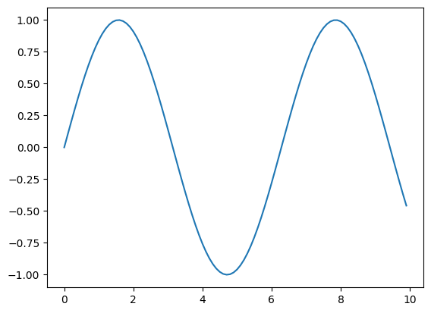

3. Customizing Plots
Matplotlib plots can be customized with titles, axis labels, grids, and more to make them easier to read and understand.
Explanation of Key Functions
- plt.title("Title"): Adds a title to the top of the plot.
- plt.xlabel("X-Label"): Sets the label for the x-axis.
- plt.ylabel("Y-Label"): Sets the label for the y-axis.
- plt.grid(True): Adds a grid to the background of the plot.
- plt.xlim(min, max): Sets the minimum and maximum range for the x-axis.
- plt.ylim(min, max): Sets the minimum and maximum range for the y-axis.
- plt.xticks(rotation=angle): Rotates the labels on the x-axis by a specified angle (in degrees).
- plt.yticks(rotation=angle): Rotates the labels on the y-axis.
Example: Fully Customized Line Plot
This example combines all the customizations into a single, informative plot showing the relationship between "Area" and "Price".
Python
# Data for the plot
area = [600, 800, 1000, 1200, 1500]
price = [15, 18, 25, 35, 40]

# Create the line plot
plt.plot(area, price)

# Add customizations
plt.title("Area vs Price") # Title
plt.xlabel("Area") # X-axis label
plt.ylabel("Price") # Y-axis label

# Set axis limits
plt.xlim(400, 2000)
plt.ylim(10, 50)

# Rotate axis ticks for readability
plt.xticks(rotation=45)
plt.yticks(rotation=90)

# Add a grid
plt.grid(True)

# Display the plot
plt.show()

4. Multi-Line Plots & Legends
You can plot multiple lines on a single graph by calling plt.plot() multiple times. To identify which line is which, you must add a legend.
Explanation
- label="label_name": This parameter is added inside the plt.plot() function to assign a name to each line.
- color="color_name": This parameter sets the color of the line.
- plt.legend(): This function displays the legend on the plot, using the names assigned in the label parameters.
Example
Python
# Data for the first line
x = [1, 2, 3]
y = [5, 7, 4]

# Data for the second line
x1 = [1, 2, 3]
y1 = [11, 14, 22]

# Plot both lines with labels and colors
plt.plot(x, y, label='First Line', color="red")
plt.plot(x1, y1, label="Second Line", color="blue")

# Add customizations
plt.title("Line Plot")
plt.xlabel("X-axis")
plt.ylabel("Y-axis")
plt.legend()
plt.grid(True)

# Display the plot
plt.show()
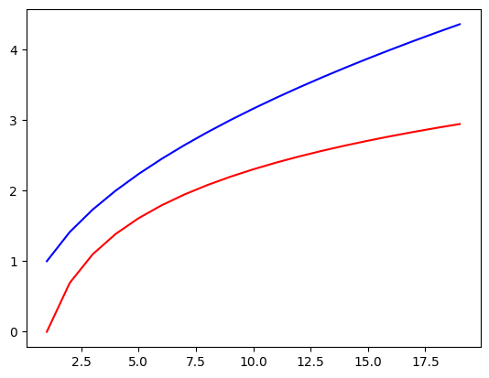

5. Bar Charts
Definition
Bar charts represent categorical data with rectangular bars. The height of each bar corresponds to the value it represents. This is useful for comparing quantities across different groups.
Example 1: Simple Bar Chart
The plt.bar() function takes the categories (x) and their corresponding values (y).
Python
# Data for the bar chart
x = [2, 4, 6, 8, 10]
y = [6, 7, 8, 2, 4]

# Create the bar chart with a label and color
plt.bar(x, y, label="bar1", color="teal")

# Add legend and display
plt.legend()
plt.show()
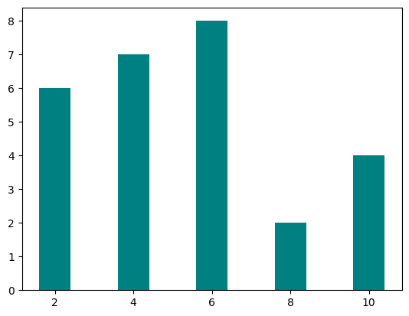
Example 2: Overlapping Bar Chart
You can plot multiple bar charts on the same axes. By default, they will overlap. This can be used for comparison, though often a grouped or stacked bar chart is preferred.
Python
# Data for the first set of bars
x = [2, 4, 6, 8, 10]
y = [6, 7, 8, 2, 4]

# Data for the second set of bars
x1 = [1, 2, 3, 4, 5]
y1 = [7, 8, 2, 4, 2]

# Plot both bar charts
plt.bar(x, y, label="bar1", color="teal")
plt.bar(x1, y1, label="bar2", color="blue")

# Add customizations
plt.title("Bar Plot")
plt.xlabel("X-axis")
plt.ylabel("Y-axis")
plt.legend()
plt.show()
